Genghis Khan Mongolian
Drink Menu
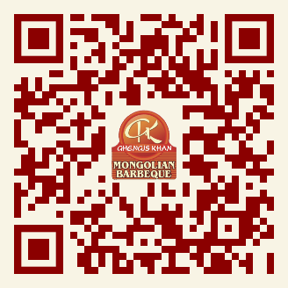

Daily Specials
Wednesday: (Kids eat Free Under 11)
*Margaritas $6.25
Thursday:
*Long Island Iced Tea $6.25
Friday: (Bottles)
*Budweiser & Bud Light $3.25
Saturday:
*Pina Coladas $6.25
Sunday:
*Bloody Mary’s $6.25

